Name: Ross Prestwich Mark _____________________/50

[**Instructions**: Remove everything that is not a heading below and fill in with your own diagrams, etc.]

## Brief introduction __/3

My Feature is primarily things related to the open world. This includes all sub-worlds, Movement, Intractable elements (such as barriers and traps)

## Use case diagram with scenario __14

### Use Case Diagrams

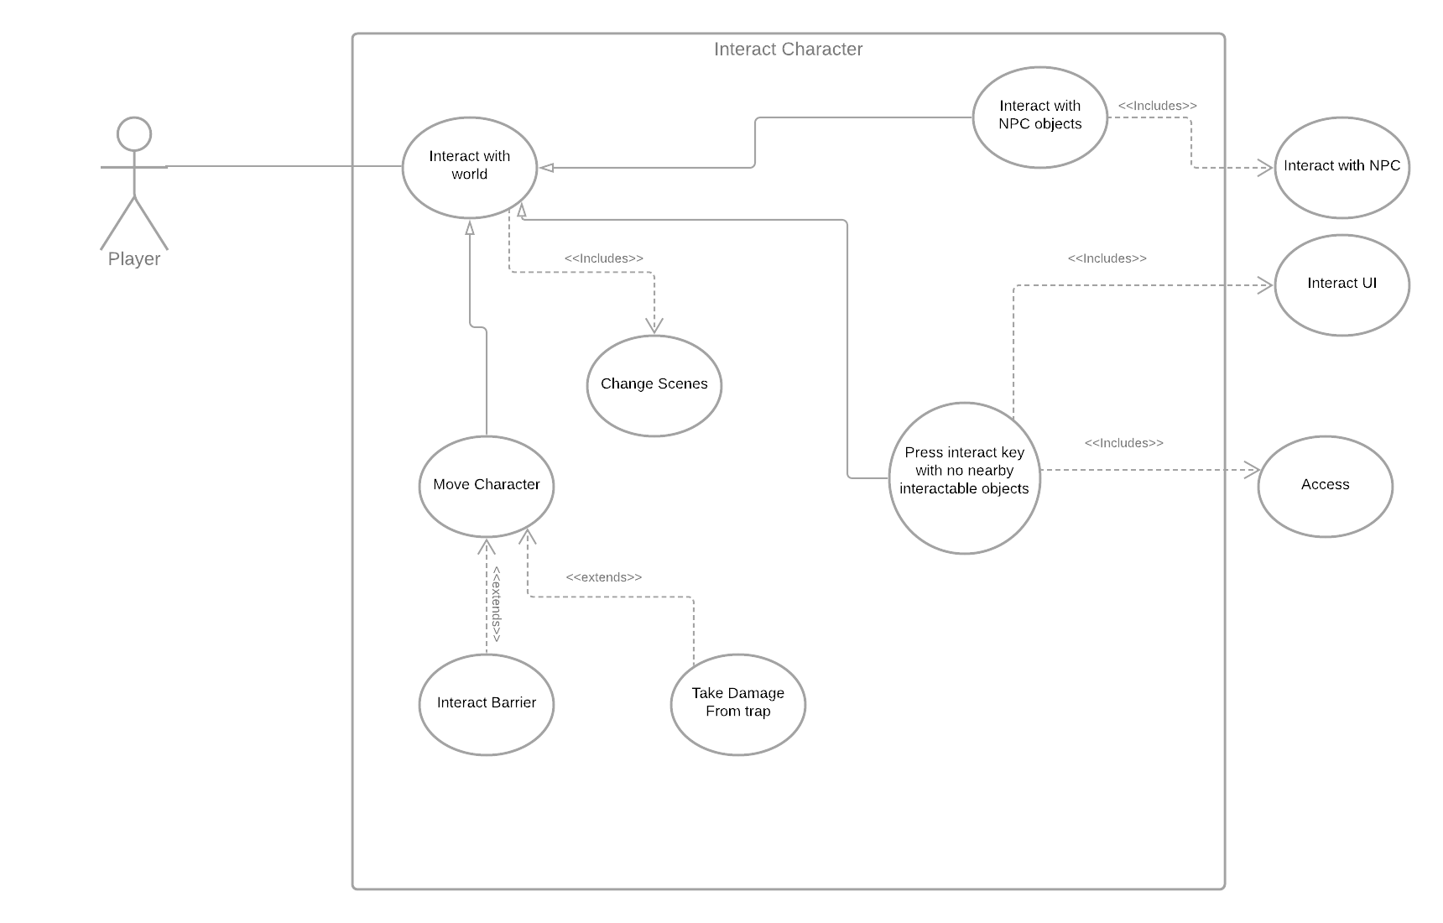

### Scenarios

**Name:** Interact with world

**Summary:** The Player Interact with objects in the world.

**Actors:** The Player

**Preconditions:** The world is open.

**Basic sequence:**

**Step 1:** Player sends Input into game

**Step 2:** actions/ functions are called depending on what inputs were sent

**Exceptions:**

**None In most general version**

**Post conditions:**

**Priority:** 1

**ID:** C01

**Name:** Move Character

**Summary:** The Player changes their location in the world.

**Actors:** The Player

**Preconditions:** The world is open.

**Basic sequence:**

**Step 1:** Player sends movement inputs into game

**Step 2:** a vector is calculated based on the input

**Step 3:** That vector is added to the players current location

**Exceptions:**

**Hits wall**

**Hits Trap**

**Post conditions:** New location

**Priority:** 1

**ID:** C01

**Name:** Interact with NPC objects

**Summary:** The Player interacts with NPC objects.

**Actors:** The Player

**Preconditions:** The player is near an NPC character.

**Basic sequence:**

**Step 1:**  Player sends interact inputs into game

**Step 2:** if near an NPC, the NPC’s interact() function is called

**Exceptions:**

**Post conditions:** NPC interact() function is running

**Priority:** 1

**ID:** C01

**Name:** Interacts with no nearby objects

**Summary:** The Player interacts with no nearby objects.

**Actors:** The Player

**Preconditions:** The player presses interact button

**Basic sequence:**

**Step 1:**  Player sends interact inputs into game

**Step 2:** inventory menu comes up

**Exceptions:**

player is near interactable object

**Post conditions:** Inventory menu is up

**Priority:** 1

**ID:** C01

## Data Flow diagram(s) from Level 0 to process description for your feature _______14

[Get the Level 0 from your team. Highlight the path to your feature]

Example:

### Data Flow Diagrams

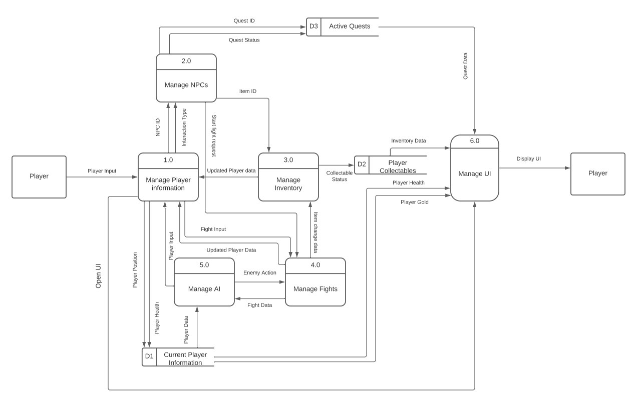

### 

### Process Descriptions

Calculate movement inputs

vector 2 = up + down

player velocity = vector 2

player location = player location + velocity

## Acceptance Tests ________9

|  |  |  |
| --- | --- | --- |
| Input | Expected output | Notes |
| up | Character moves up |  |
| down | Character moves down |  |
| left | Character moves left |  |
| right | Character moves right |  |
| interact | Interact function is called | Lots of sub-cases for this one |

## Timeline _________/10

[Figure out the tasks required to complete your feature]

Example:

### Work items

|  |  |  |
| --- | --- | --- |
| Task | Duration (PWks) | Predecessor Task(s) |
| 1. create main world map | 5 | 5 |
| 2. Movement | 6 | 5 |
| 3. Create Barriers and Traps | 6 | 5 |
| 4. Create Interactable objects | 2 | 3 |
| 5. Create other areas | 6 | 5 |

|  |  |  |  |  |  |  |  |  |  |  |  |  |  |  |  |
| --- | --- | --- | --- | --- | --- | --- | --- | --- | --- | --- | --- | --- | --- | --- | --- |
| Ross |  |  |  |  |  |  |  |  |  |  |  |  |  |  |  |
| Create Main world map | 5 |  |  |  |  |  |  |  |  |  |  |  |  |  |  |
| Movement (including accessing other places) | 5 |  |  |  |  |  |  |  |  |  |  |  |  |  |  |
| Create barries/traps | 5 |  |  |  |  |  |  |  |  |  |  |  |  |  |  |
| Create Interactable player objects | 3 |  |  |  |  |  |  |  |  |  |  |  |  |  |  |
| Create dungeons/ other areas | 5 |  |  |  |  |  |  |  |  |  |  |  |  |  |  |
| total | 23 |  |  |  |  |  |  |  |  |  |  |  |  |  |  |